III B. Tech I Semester Regular Examinations - December, 2023
ADVANCED DATA STRUCTURES
(CSE)

Time: 150 Min Max. Marks:80M

SECTION – A
Answer all Four questions 4×10M=40M
1. a) When developing a file system that uses a hash table for indexing file metadata, how
would you manage situations where different files hash to the same index, and when the
memory is not enough to store the file metadata?
b) Describe techniques to handle the above two situations effectively for rapid file retrieval and management.
c) Your tasked to construct a hash table for the input: 30, 20, 56, 75, 31, 19, 80, 99 using
the hash function h(x) = x % 11 where the size of table is m = 11. You must do it in two
ways:
- In the first way, you should use a linear data structure where insertion of a new
element has constant time complexity.
- In the second way, you should follow a technique where if a position is already filled, you should check for the next immediate empty position.
- Explain in which category does these two ways fall in and construct 2 hash table, one for each method mentioned.
2. a) What is meant by splaying and list different types of rotations used in splaying of the
tree.
b) Splay ‘E’ for given examples below
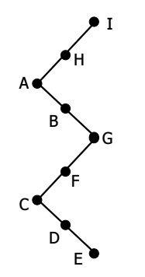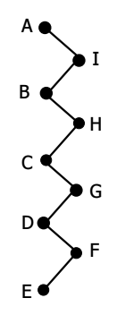
i) ii)

c) Given below tree follows the properties of a Binary search tree. You are given a key 8 which may or may not be present in the tree. Your tasked to split the given tree in to two parts based on the given key 8. Use the approach which involves the use of 2 splay operations
- one splay before splitting the tree
- one splay for maintaining the BST property of the tree.
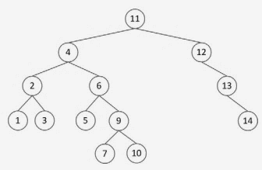
3. a) You have invested your savings in the stock market to make profits, to make huge
profits you need to keep track of lowest stock price every day, Given the prices of a
stock for the 11 consecutive days stock prices = {96, 87, 64, 59, 49, 42, 31, 27, 16, 8).
- Create a data structure where you can add the stock prices every day for all 11 days such that at any point of time you can instantly get the stock with the lowest price.
- Give algorithm for creating such data structure and show each step for insertion of 11 stock prices into that data structure.
b) Does the process of creating this data structure for the provided data fall within the
best case or worst-case scenario? Justify your answer?

4. a) In a land of coded mysteries, a determined adventurer embarked on a quest. Armed with a main string and a pattern, the intrepid explorer sought to uncover hidden sequences. In the first chapter of the adventure, they traversed the string "CODESDOPE", seeking the elusive pattern "CODE". With unwavering resolve, they discovered the pattern at location 0, marking the beginning of their triumph. In the next chapter, a more complex tale unfolded, as they delved into the string "ABAAABAAAAABBAAAABA" in pursuit of the pattern "AAAB". The explorer aim is to ” reduce the iterations by avoiding the redundant comparisons for which he pre-processes using the prefixes of the string to build a table”. Noting this help the explorer to find out the indexes where the pattern matches the string.
b) Discuss the cases where the above algorithm performs best, average and worse, discuss the time complexities of each case

SECTION – B
Answer all Two questions 2x20M=40M

5. a) Your tasked to insert the following elements into the hash table of size 10 using the linear probing method 99, 79, 29, 9, 69, 39, 89, 49, 59, 19 using the hash function h(x) = x % 10. What problem has you encountered and give the ways you can opt to eliminate this problem
b) what approach does merge sort follows to sort the elements, give algorithm for merge sort compare the performance of merge sort vs quick sort if the elements are already sorted.

c) Imagine a virtual classroom where nine students have received marks: 10, 20, 5, 15, 30, 25, 35, 40, and 3. Each student's academic story is unique, and they eagerly await to see how their marks are structured within a special BST tree.

Explain how each student's marks find their place within this balanced structure. Along the way, weave into the tale the removal of specific records, including 25, 15, and 20. Share how the system ensures that the academic data remains organized and easily accessible while handling the addition and deletion of records within this special BST tree.
In this academic adventure, describe the process of organizing student marks, including the addition and deletion of specific records, within a structured system designed to maintain academic order and allow for efficient analysis and review special BST Tree – Each Node in this tree can store k-1 values where k value represents the number of children per node.
d) What are Red Black Trees. Define the rules for a Tree to be a Red Black Tree. Insert the elements 8, 18, 5, 15, 17, 25, 40, and 80 into a Red Black Tree and show the resultant tree after each insertion.
6. a) Describe the concept of a binary heap and its types. Provide array representations of
binary heaps, and describe their distinct characteristics?
b) Develop the solution for the following
(i) Binomial heaps use a _________ structure, allowing for the efficient implementation of various operations.
(ii) What is the main advantage of using binomial heaps over binary heaps?
(iii) For the given binomial heap draw the detailed representation using root list highlighting the parent, sibling relationship of the nodes in the binomial heap – Node representation
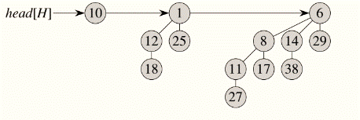
c) Using bad match table method of Boyer Moore algorithm find the pattern “TEAMMAST” in the string “WELCOMETOTEAMMAST”
d) You’re a network operator who is assigned a work of maintaining and manipulating a larger database of IP addresses. Manipulation includes insertions and retrieval of the IP addresses Your goal is to minimize memory usage while maintaining efficient search operations. Describe the step-by-step process of constructing a data structure and provide an example of how it would look after inserting a few IP addresses. Additionally, discuss the advantages and trade-offs of it for IP addresses storage.
The IP address include digits from [0, 1, 2, 3, 4, 5, 6, 7, 8, 9] and a delimiter ‘.’ to separate the sub addresses Ex: 192.168.0.1, 192.168.0.2, 192.168.2.1 construct a standard Trie for few IP addresses and construct the data structure selected by you considering the digits alone, also show how your data structure has more advantage in storage and retrieval of IP addressed respectively.

